CREATE UI TO INTERACT WITH APPLICATION

|  |  |
| --- | --- |
| Date | 12 November 2022 |
| Team ID | PNT2022TMID30108 |
| Project Name | Skills/Job Recommender Application |

# Design an application with following specification

1. **registration page**

# login page

1. **Job List Page**

# Home page

## index.html

<!DOCTYPE html>

<html lang="en">

<head>

<meta charset="UTF-8" />

<meta name="viewport" content="width=device-width, initial-scale=1.0" />

<meta http-equiv="X-UA-Compatible" content="ie=edge" />

<title>Spinz.co</title>

<!--

DREAM PULSE

-->

<link rel="stylesheet" href="https://fonts.googleapis.com/css?family=Open+Sans:400,600" />

<link rel="stylesheet" href="css/all.min.css" />

<link rel="stylesheet" href="css/bootstrap.min.css" />

<link rel="stylesheet" href="slick/slick.css"/>

<link rel="stylesheet" href="slick/slick-theme.css"/>

<link rel="stylesheet" href="css/magnific-popup.css">

<link rel="stylesheet" href="css/templatemo-dream-pulse.css" />

</head>

<body>

<main class="container-fluid">

<div class="column">

<nav id="tmSidebar" class="tm-bg-black-transparent tm-sidebar">

<button class="navbar-toggler" type="button" aria-label="Toggle navigation">

<i class="fas fa-bars"></i>

</button>

<div class="tm-sidebar-sticky">

<div class="tm-brand-box">

<div class="tm-double-border-1">

<div class="tm-double-border-2">

<h1 class="tm-brand text-uppercase">Spinz.co</h1>

</div>

</div>

</div>

<ul id="tmMainNav" class="nav flex-column text-uppercase text-right tm-main-nav">

<li class="nav-item">

<a href="#work" class="nav-link">

<span class="d-inline-block mr-3">Login</span>

<span class="d-inline-block tm-white-rect"></span>

</a>

</li>

<li class="nav-item">

<a href="#intro" class="nav-link active">

<span class="d-inline-block mr-3">Intro</span>

<span class="d-inline-block tm-white-rect"></span>

</a>

</li>

<li class="nav-item">

<a href="#about" class="nav-link">

<span class="d-inline-block mr-3">About</span>

<span class="d-inline-block tm-white-rect"></span>

</a>

<li class="nav-item">

<a href="#clients" class="nav-link">

<span class="d-inline-block mr-3"></span>

<span class="d-inline-block tm-white-rect"></span>

</a>

</li>

<li class="nav-item">

<a href="#talk" class="nav-link">

<span class="d-inline-block mr-3">Let's Talk</span>

<span class="d-inline-block tm-white-rect"></span>

</a>

</li>

</ul>

<ul class="nav flex-row tm-social-links">

<li class="nav-item">

<a href="https://facebook.com" class="nav-link tm-social-link">

<i class="fab fa-facebook-f"></i>

</a>

</li>

<li class="nav-item">

<a href="https://twitter.com" class="nav-link tm-social-link">

<i class="fab fa-twitter"></i>

</a>

</li>

<li class="nav-item">

<a href="https://dribbble.com" class="nav-link tm-social-link">

<i class="fab fa-dribbble"></i>

</a>

</li>

<li class="nav-item">

<a href="https://linkedin.com" class="nav-link tm-social-link">

<i class="fab fa-linkedin-in"></i>

</a>

</li>

</ul>

<footer class="text-center text-white small">

<p class="mb--0 mb-2"></p>

</footer>

</div>

</nav>

<main role="main" class="ml-sm-auto col-12">

<div

class="parallax-window"

data-parallax="scroll"

data-image-src="img/dream-pulse-header.jpg">

<div class="tm-section-wrap">

<section id="intro" class="tm-section">

<div class="tm-bg-white-transparent tm-intro">

<h2 class="tm-section-title mb-5 text-uppercase tm-color-primary">LOGIN</h2>

<p class="tm-color-gray">

<a href="Login.html"><button id="input_2" type="submit" class="btn btn-block btn-primary" data-component="button" data-content="">

Login&nbsp;Now

</button></a>

<p></p><a href="Registration_Form.html"><button id="input_2" type="submit" class="btn btn-block btn-primary" data-component="button" data-content="">

Register&nbsp;Now

</button></a>

<p></p><a href="job-list.html"><button id="input_2" type="submit" class="btn btn-block btn-primary" data-component="button" data-content="">

Job-list&nbsp;Now

</button></a>

<p> </p>

<p class="mb-0 tm-color-red">

</p>

</div>

</section>

</div>

</div>

<div

class="parallax-window"

data-parallax="scroll"

data-image-src="img/dream-pulse-header.jpg">

<div class="tm-section-wrap">

<section id="intro" class="tm-section">

<div class="tm-bg-white-transparent tm-intro">

<h2 class="tm-section-title mb-5 text-uppercase tm-color-primary">Spinz.co</h2>

<p class="tm-color-gray">

Job Search Skills, is designed to

give anyone who is looking for work the skillset they need to find the job

they are searching for. Searching for a new job is both an exciting and

stressful process. From students looking for internships to experienced

professionals, job search skills can be invaluable for almost everyone. With

this free online course, gain a few more of these skills, today.

</p>

<p class="mb-0 tm-color-">

</p>

</div>

</section>

</div>

</div>

<div class="parallax-window"

data-parallax="scroll"

data-image-src="img/dream-pulse-header.jpg">

<div class="tm-section-wrap">

<section id="" class="tm-section">

<div class="tm-bg-white-transparent tm-intro">

<div><i class="fas fa-6x fa-balance-scale mb-5 tm-section-icon"></i></div>

<h2 class="tm-section-title tm-color-primary mb-4">About Us</h2>

<p class="mb-5"><button id="input_2" type="submit" class="btn btn-block btn-primary" data-component="button" data-content="">

Login&nbsp;Now

</button>

“Spinz.co” connects you with other professionals also with companies and recruiters. Along with professionals, it also serves companies and even charges for providing certain premium services.

❑ “Spinz.co” is solution to increase your professional network and find new opportunities. Be it finding new networking opportunities, potential employees, marketing of new campaigns, searching for a sales lead or learning business concepts, “Spinz.co” business solutions have services to fulfil most of these needs.

</p>

<p>

</p>

</div>

</main>

</div>

</div>

<script src="js/jquery.min.js"></script>

<script src="js/jquery.singlePageNav.min.js"></script>

<script src="js/parallax.min.js"></script>

<script src="slick/slick.min.js"></script>

<script src="js/jquery.magnific-popup.min.js"></script>

<script src="js/templatemo-scripts.js"></script>

</body>

</html>

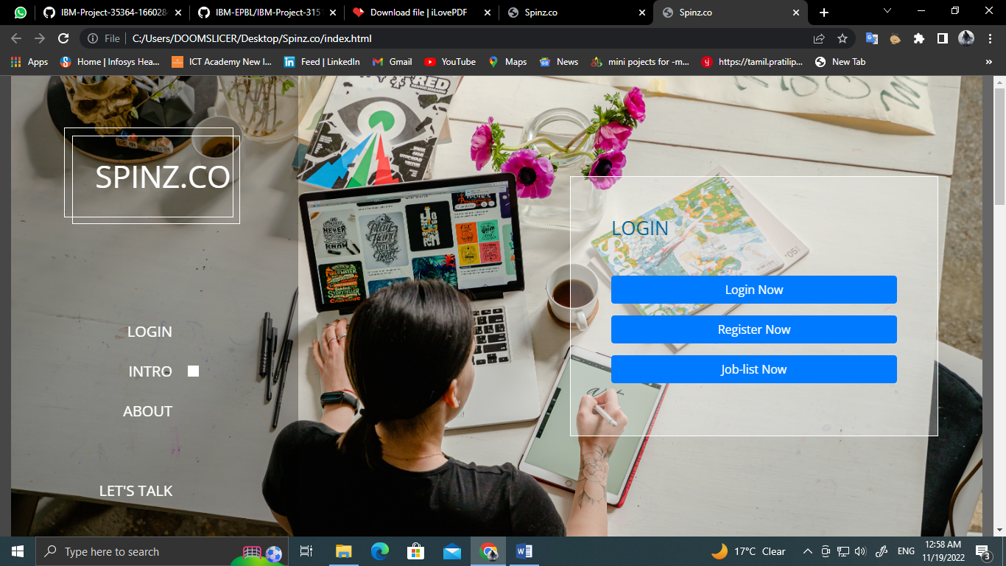

</div>

<div class="pass"><a href="#">Forgot password?</a></div>

<div class="row button">

<input type="submit" value="Login">

</div>

<div class="signup-link">Not a member? <a href="#">Signup now</a></div>

</form>

</div>

</div>

</body>

</html>

## Style.css

@import url('https://fonts.googleapis.com/css2?family=Poppins:wght@400;500;600;700&display= s wap'); *{ margin: 0; padding: 0; box-sizing: border-box; font-family: 'Poppins',sans- serif;

}

body{ background: #1abc9c; overflow: hidden;

}

::selection{ background: rgba(26,188,156,0.3);

}

.container{ max- width: 440px; padding: 0 20px; margin: 170px auto;

}

.wrapper{ width: 100%; background: #fff; border-radius: 5px; box-shadow: 0px 4px 10px 1px rgba(0,0,0,0.1);

}

.wrapper .title{ height: 90px; background: #16a085; border-radius: 5px 5px 0 0;

color: #fff; font- size: 30px; font- weight: 600;

display: flex; align- items: center; justify- content: center;

}

.wrapper form{ padding: 30px 25px 25px 25px;

}

.wrapper form .row{ height: 45px;

margin-bottom: 15px; position: relative;

}

.wrapper form .row input{ height: 100%; width:

100%; outline: none; padding-left: 60px; border-radius: 5px;

border: 1px solid lightgrey; font-size: 16px; transition:

all 0.3s ease;

}

form .row input:focus{ border-color: #16a085; box- shadow: inset 0px 0px 2px 2px rgba(26,188,156,0.25);

}

form .row input::placeholder{ color: #999;

}

.wrapper form .row i{ position: absolute; width: 47px; height: 100%;

color: #fff; font- size: 18px;

background: #16a085; border: 1px solid #16a085; border-radius: 5px 0 0 5px; display: flex; align-items: center; justify-content: center;

}

.wrapper form .pass{ margin: -8px 0 20px 0;

}

.wrapper form .pass a{ color: #16a085; font-

size: 17px; text- decoration: none;

}

.wrapper form .pass a:hover{ text- decoration: underline;

}

.wrapper form .button input{ color: #fff; font-size:

20px; font-weight: 500; padding-left: 0px; background: #16a085; border: 1px solid #16a085; cursor: pointer;

}

form .button input:hover{ background: #12876f;

}

.wrapper form .signup-link{ text-align: center;

margin-top: 20px; font- size: 17px;

}

.wrapper form .signup-link a{ color: #16a085; text- decoration: none;

}

form .signup-link a:hover{ text- decoration: underline;